COVID-19
“Return to Learn” Summary
House Bill: 5911, 5912, 5913
Fall 2020

Prepared by Ferris State University
Charter Schools Office

Instructions

This summary and guide has been prepared for all Ferris State University public school academy stakeholders. Our intent is to try to condense the most import information you need to know regarding the recently enacted Return to Learn legislation (HB 5911, 5912, 5913). We hope you find it helpful.

Link for House Bill 5911 of 2020:
http://www.legislature.mi.gov/documents/2019-2020/publicact/pdf/2020-PA-0147.pdf

Link for House Bill 5912 of 2020:
http://www.legislature.mi.gov/documents/2019-2020/publicact/pdf/2020-PA-0148.pdf

Link for House Bill 5913 of 2020:
http://www.legislature.mi.gov/documents/2019-2020/publicact/pdf/2020-PA-0149.pdf

Most importantly, please be aware that:

- A district intending to provide instruction under an extended COVID-19 Learning Plan MUST submit the Plan to its ISD or authorizing body, as applicable, by September 30, 2020 (Via Epicenter). A TEMPLATE for this submission is included in this guide.

- The ISD or authorizing body must approve the Plan if it includes all of the elements listed above, and will transmit copies of the plan to the Superintendent of Public Instruction and State Treasurer.

- Approved Plans must be made accessible through the transparency reporting link on the district’s website by October 1, 2020.

Please do not hesitate to contact us if you have any questions.

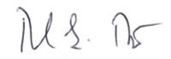
Sincerely,

Ronald S. Rizzo, Ph.D.
Director

House Bill 5911 of 2020
This bill pertains to requirements concerning virtual courses and modifies/amends sec. 21f of 1979 PA 94 (MCL 388.1621f) as following:
- Amends the State School Aid Act to specify that the Act's requirements and prohibitions concerning virtual courses would not apply to virtual courses offered as part of pandemic learning. As used in this Bill, “pandemic learning” means a mode of pupil instruction provided as a result of the COVID-19 pandemic.

Link for House Bill 5911 of 2020:
http://www.legislature.mi.gov/documents/2019-2020/publicact/pdf/2020-PA-0147.pdf

House Bill 5912 of 2020

- Requires, for 2020-21 only, each district superintendent to submit and certify to Center for Educational Performance and Information (CEPI) and the intermediate superintendent the number of pupils engaged in pandemic learning for fall 2020 and spring 2021.

- Specifies that a provision requiring the Department of Education (MDE) to pay a district State aid in a reduced amount if a district does not have at least 75% of its membership on a day of pupil instruction would not apply for the 2020-21 school year only.

- Requires, for the 2020-21 school year only, at least one two-way interaction per month for at least 75% of pupils in order to receive full State aid payments; if this requirement were not met, districts would face a reduction in State aid payments for the month, proportionate to the shortfall in attendance compared to 75%.

- Waive, for the 2020-21 school year only, the minimum number of hours and days of pupil instruction, and, instead, require districts to provide pupil instruction that resulted in an amount of hours and days necessary to deliver the educational or course content that would have been delivered in 180 days and 1,098 hours in a school year in which pandemic learning was not provided and that would have led to course completion.

Link for House Bill 5912 of 2020:
http://www.legislature.mi.gov/documents/2019-2020/publicact/pdf/2020-PA-0148.pdf

Page |1
House Bill 5913 of 2020-(Section 98a)

The State requires a district to provide an approved extended COVID-19 Learning Plan (CLP) in order to receive State aid for 2020-21. An extended CLP needs to include all of the following:

- A statement indicating why an extended COVID-19 Learning Plan is necessary to increase student engagement and achievement for the 2020-2021 school year.

- The educational goals expected to be achieved for the 2020-2021 school year. The district would have to establish all of its goals under this provision by September 15, 2020. The CLP needs to specify which educational goals are expected to be achieved by the middle of the school year and which by the end of the school year.

All of the following would apply to these educational goals:

- They must include increased student achievement or, if it can be validly and reliably measured using benchmark assessments, growth on those assessments in the aggregate and for all subgroups of students.

- They must include an assurance that the district will select benchmark assessments aligned to state standards and an assurance that the district will administer them to all students to determine whether students are making meaningful progress toward mastery of the standards.

- They must be measurable through benchmark assessments. (We recommend you use your Contractual Educational Goals, set mid-year goals based on 50% of the annual goals, and state the plans to use NWEA assessments at the beginning, middle, and end of school year.)

- A description of how instruction will be delivered. (Instruction in this instance may be delivered at school or at a different location, in person, online, digitally, by other remote means, in a synchronous or asynchronous format, or through any combination of these, but it must conform to the description submitted.) The district’s Board or Board of Directors must meet monthly after the Plan’s submission to reconfirm how instruction will be delivered during the 2020-2021 school year, and must solicit public comment from parents and guardians during the meeting. If the description of instruction changed following one of these meetings, the district must deliver instruction according to the reconfirmed description.

- A description of how instruction for core academic areas provided under the Plan will expose each student to standards comparable to in-person instruction and a description of how student progress will be graded or reported to the student and his or her parents or guardians.

Page | 2
- If the district is delivering instruction virtually, an assurance and description of how students will be provided with equitable access to technology and the internet necessary to participate in instruction. (This would not prohibit the district from providing instruction through non-virtual educational materials.)

- A description of how the district will ensure that students with disabilities will be provided with equitable access to instruction accommodation in accordance with state and federal law.

- A requirement that the district, in consultation with the local health department and district employees, develop districtwide guidelines concerning pupil instruction based on local data on key metrics. However, the ultimate decision on instruction rests with each district. (Key metrics would include COVID-19 cases, hospitalizations, deaths, positive tests, health care capacity, and testing, tracking, and containment infrastructure.)

- A provision that, if the district determines that it is safe to provide in-person instruction, it will prioritize instruction for grades K to 5.

- A requirement that the district ensure that at least two two-way interactions occur between a student and at least one of his or her teachers during each week of the school year for at least 75% of students in the district. These could apply toward the district’s two-way interaction requirement under HB 5912. A district would have to publicly announce its weekly interaction rates at its monthly reconfirmation meetings and make those rates available on its website.

- A district intending to provide instruction under an extended CLP would have to submit the Plan to its ISD or authorizing body, as applicable, by September 30, 2020.

- The ISD or authorizing body must approve the Plan if it includes all of the elements listed above, and would have to transmit copies of the plan to the superintendent of public instruction and state treasurer.

- Approved Plans must be made accessible through the transparency reporting link on the district’s website by October 1, 2020.

- By February 1, 2021, the district needs to create a report concerning progress toward the plan’s mid-year goals and ensure that it is accessible through the district’s website. (The CSO will provide a template for this report before the end of the calendar year.)

- Additionally, by the last day of the school year, the district needs to create a report concerning progress toward end-of-year goals and ensure that it is accessible through the website. (we recommend you state in your Plan that you will create these two reports)

Page | 3
House Bill 5913 of 2020-(Section-1)

This Bill requires all districts to develop an extended COVID-19 learning plan with maximum flexibility to adapt their programs to respond to the pandemic.

- Modifies the definition of "membership" for 2020-21. The formula would be 75% weighted on the 2019-20 membership blend plus 25% weighted on the 2020-21 membership blend.

- A district would be considered to be in session for Count Day when providing pupil instruction under an approved extended COVID-19 Learning Plan. Membership during “pandemic learning", (pupils to be counted) occurs if instruction is in person, virtually, or some combination of these.

- Only for 2020-21, Student Count is a supplemental pupil count of the number of pupils engaged in pandemic learning for spring of 2021, or for a district that operated as a cyber school, the number of full-time equated pupils in grades K to 12 actually enrolled and in regular attendance in the district on the supplemental count day.

- Requires a district to ensure that at least one two-way interaction between a pupil and one of the pupil's teachers occurs during the week of count day, the week of the supplemental count and during each week for three consecutive weeks of each count day.

- Requirements for the extended COVID-19 Learning Plan include educational goals expected to be achieved for the 2020-21 school year, a description of how instruction would be delivered for the 2020-21 school year, and a requirement that a district ensure two two-way interactions between a pupil and his or her teacher during each week of the school year for at least 75% of the pupils enrolled in the district.

- Require districts to establish educational goals by September 15, 2020. Kindergarten Entry Operation Tool (MKEO or KRA) is suspended for 2020-21.

- Requirements for an approved extended COVID-19 learning plan:

- Each district superintendent must submit and certify to CEPI and the MDE the number of pupils engaged in pandemic learning for fall 2020 and spring 2021.
- A district must administer one benchmark assessment in Reading and Math for grades K-8 within the first nine weeks of the school year and a second before the last day of the school year from a list approved by MDE.
- Require a district, by June 30, 2021, to send the aggregate district-level data from a Benchmark assessment to the Michigan data hub network, which would have to compile the data and send it to CEPI.

Page | 4
- Require a district to provide progress reports on its education goals approved in the extended COVID-19 learning plan by February 1, 2021, and to ensure that these reports are placed on the district’s website.
- The benchmark assessment data is prohibited from being used for the State accountability system.
- Specify that, if a district used a local benchmark assessment, the district would have to report to the MDE and CEPI the assessment that was administered and how it measured changes, including losses in learning.

- A higher education institution, or other entity that is not a State governmental Entity, is to provide an assessment of distance learning programs used that were effective at meeting educational goals and attainment, provide for an assessment of how the programs operated, provide for an assessment of best practices to be replicated by schools engaged in distance learning, and note distance learning models that were ineffective in achieving educational goals.

Link for House Bill 5913 of 2020:
http://www.legislature.mi.gov/documents/2019-2020/publicact/pdf/2020-PA-0149.pdf

The Ferris State University Charter Schools Office has provided a template for the COVID-19 Learning Plan-see attached

Page | 5
Choose an item.

Extended COVID-19 Learning Plan

Address of School District: 16911 Eastland, Roseville, MI 48066

District Code Number: 50902

Building Code Number(s): Conner Creek Academy East: 8726 Michigan Collegiate: 09089

District Contact Person: Russel Woodruff

District Contact Person Email Address: Woodruffr@connercreekeast.org

Local Public Health Department: Macomb County Health Department

Local Public Health Department Contact Person Email Address: https://health.macombgov.org/Health-Contact
(586) 469-5510
William J. Ridella, M.P.H., M.B.A.
Director/Health Officer

Name of Intermediate School District: MISD

Name of Authorizing Body: Ferris State University

Date of Adoption by Board of Directors: Click here to enter a date.

Assurances

- The Academy will administer an approved benchmark assessment, or local benchmark assessment, or any combination thereof, to all pupils in grades K to 8 to measure proficiency in reading and mathematics within the first nine weeks of the 2020-2021 school year.

- Within thirty days after the approval of its Extended COVID-19 Learning Plan, and every 30 days thereafter, the Academy, at a meeting of its board of directors, will re-confirm how instruction is delivered during the 2020-2021 school year and will solicit public comment, at a public meeting, from the parents or legal guardians enrolled in the Academy.

- If delivering pupil instruction virtually, the Academy will expose each pupil to the academic standards that apply for each pupil’s grade level or courses in the same scope and sequence as the Academy had planned for that exposure to occur for in-person instruction.

- If delivering pupil instruction virtually, the Academy will provide pupils with equitable access to technology and the internet necessary to participate in instruction.

- The Academy will ensure that students with disabilities will be provided with equitable access to instruction and accommodation in accordance with applicable state and federal laws, rules and regulations.

- The Academy, in consultation with a local health department, and district employees, will develop guidelines concerning appropriate methods for delivering pupil instruction for the 2020-2021 school year that are based on local data that are based on key metrics. A determination concerning the method for delivering pupil instruction shall remain at the Academy Board’s discretion. Key metrics that the Academy will consider shall include at least all of the following:

  - COVID-19 Cases or Positive COVID-19 tests
  - Hospitalizations due to COVID-19
  - Number of deaths resulting from COVID-19 over a 14-day period
  - COVID-19 cases for each day for each 1 million individuals
  - The percentage of positive COVID-19 tests over a 4-week period
  - Health capacity strength
  - Testing, tracing, and containment infrastructure with regard to COVID-19

- If the Academy determines that it is safe to provide in-person pupil instruction to pupils, the Academy will prioritize providing in-person pupil instruction to pupils in grades K to 5 who are enrolled in the Academy.

- The Academy will ensure that two (2), 2-way interactions occur between a pupil enrolled in the Academy and the pupil’s teacher or at least one (1) of the pupil’s teachers during each week of the school year for at least 75% of the pupils enrolled in the Academy. The Academy will publicly announce its weekly interaction rates at each Academy Board meeting where it reconfirm how instruction is being delivered , beginning 30 days after approval of its Extended COVID-19 Learning Plan, and every 30 days thereafter. The Academy will make those rates available through the transparency reporting link located on the Academy website each month for the 2020-2021 school year.

- The Academy will create and make available on its transparency reporting link located on the Academy’s website, a report concerning the progress made in meeting the educational goals contained in its Extended COVID-19 Learning Plan not later than February 1, 2021, for goals its expected would be achieved by the middle of the school year and not later than the last day of school of the 2020-2021 school year for goals the Academy expected would be achieved by the end of the school year.

Dave Chegash
President of the Board of Directors

Click here to enter a date.
Date

Choose an item.

Introduction and Overview

- Provide a statement indicating why an Extended COVID-19 Learning Plan is necessary to increase pupil engagement and achievement for the 2020-2021 school year.

Academy Statement:

The Extended Learning Plan is necessary as it provides specific details about how the academy will meet its educational goals and how instruction will be delivered/provided. The academy has provided virtual learning platforms for students to ensure engagement and increase achievement while remote. The remote learning schedules creates a sense of routine and consistency for the students.

The Extended Learning Plan also ensures the equitability to technology, curriculum and instruction for all students, including students with disabilities. The academy has prepared supports that can be provided virtually for all students with disabilities. This plan will outline district-wide guidelines concerning instruction based on the overall health and safety of the community. Each month, the academy will assess the plan with regard to the city and state numbers of transmission. The academy will be preparing a return prioritizing K-5 students first. Much of this preparation is stated within the FSU-CSO Covid-19 Preparedness and Response Plan for Phase 4 and Phase 5 learning.

Additionally, the academy’s plan will delineate how we track attendance and ensure two-way communication throughout the school year. Attendance and communication will result in increased pupil engagement and achievement. Lastly, the academy will adhere to the compliance requirements as stated in various house bills and by Ferris State University.

Educational Goals

- Outline and describe the educational goals expected to be achieved for the 2020-2021 school year. It is the expectation of your authorizing body that your educational goal is aligned to the educational goal within your charter contract. The Academy must establish all of its goals by no later than September 30, 2020.
- Specify which goals are expected to be achieved by the middle of the school year and which goals are expected to be achieved by the end of the school year.
- Ensure that all of the following apply to the educational goals described in this section: (a) The goals must include increased pupil achievement or, if growth can be validly and reliably measured using a benchmark assessment or benchmark assessments, growth on a benchmark assessment in the aggregate and for all subgroups of pupils; (b) The goals must select a benchmark assessment or benchmark assessments that are aligned to state standards and an assurance that the Academy shall administer the benchmark assessment or benchmark assessments to all pupils to determine whether pupils are making meaningful progress toward mastery of these standards; and (c) The goals must be measurable through a benchmark assessment or benchmark assessments.
- Ensure that the benchmark assessment used to measure progress toward attainment of the goals is approved by the Michigan Department of Education and meets all of the following: (a) Is one of the most commonly administered benchmark assessments in the state; (b) Is aligned to the content standards of the state; (c) Complements the state’s summative assessment system; (d) Is internet-delivered and includes a standards-based assessment using a computer-adaptive model to target the instructional level of each pupil; (e) Provides information on pupil achievement with regard to learning content required in a given year or grade span; (f) Provides immediate feedback to pupils and teachers; (g) Is nationally normed; and (h) Provides multiple measures of growth and provide for multiple testing opportunities.
- To the extent practicable, the Academy shall administer the same benchmark assessment or benchmark assessments that it administered to pupils in previous years.

Academy Statement:

Mid-Year Growth Goal:

K-8 NWEA MAP - Using Winter NWEA MAP results, our students will attain 50% of their yearly growth target on the Reading and Math assessments.

End-Year Growth/Achievement Goals:

Measure 1: Student Growth Towards Achievement

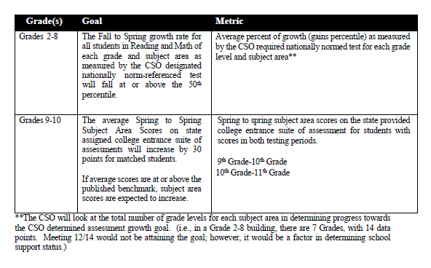

Measure 2: Student Achievement

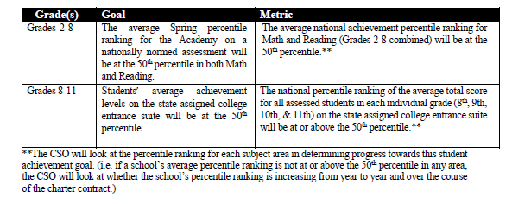

Measure 3: Student Achievement & Growth: Relative Performance and State/Federal Accountability
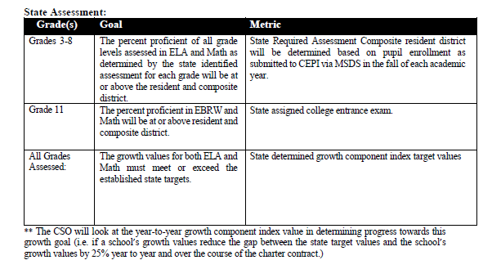

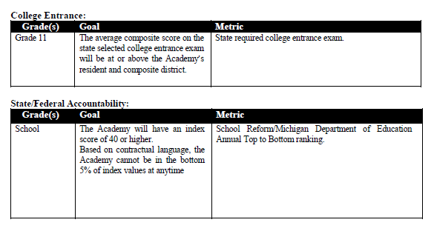
Instructional Delivery & Exposure to Core Content

- Describe how and where instruction will be delivered during the 2020-2021 school year. (E.G., in-person, online, digitally, by other remote means, in a synchronous or asynchronous format, or any combination thereof).
- Describe how instruction for core academic areas will expose each pupil to the academic standards that apply for each pupil’s grade level or course in the same scope and sequence as the Academy had planned for that exposure to occur for in-person instruction.
- Describe how pupil progress toward mastery of the standards described within this section will be graded or otherwise reported to the pupil and the pupil’s parent or legal guardian.

Academy Statement:

All students of Conner Creek Academy East district will be provided instruction from a variety of mediums while remote learning. The students’ daily learning schedule will include synchronous and asynchronous opportunities. We have also opened a Learning Lab housed at the elementary for students who do not have access to adult supervision while at home.

Conner Creek Academy East school district is striving for a minimum of 80% daily attendance. Teachers and administrators will be using multiple forms of two way communication provided by the district working together with the intermediate school district.

At Conner Creek Academy East Elementary, students utilize G-Suite for Education to access their Google Classroom daily. Daily/Weekly objectives, standards and student expectations are communicated within Google. K-6 students will receive instruction via video conferencing daily. K-6 students also will utilize the Buzz platform to access Accelerate Education.

At Michigan Collegiate Middle and High School, students utilize G-Suite for Education to access their Google Classroom daily. Daily/Weekly objectives, standards and student expectations are communicated within Google. Students receive synchronous instruction via video conferencing daily. Additional afternoon support will be given to students through teacher-student conferences. Students will access Edgenuity as part of their course curriculum as well.

Through Accelerate Education, Edgenuity and Google Classrooms students will have access to curriculum and instruction based on Common Core State Standards. Teachers will integrate state-standards that are not fully implemented within the virtual courses. Objective progress will be assessed prior to returning to face-to-face learning so staff can transition in academic appropriately.

Students within the district will be assessed and graded based on their participation, progress within the virtual courses and mastery/proficiency on state-standards. Students are expected to complete and submit assignments and assessments through the online learning platforms provided. Reports from virtual courseware, formal progress reports, narrative feedback and report cards will be distributed to families. Student conferencing, phone calls, emails and other forms of two-way communication will be provided frequently throughout the week to ensure student progress, pace and participation.

Reading specialists, special education teachers, speech pathologist, social worker/counselors, paraprofessionals and/or other support staff will provide extra services individually or in small groups to enhance learning for at-risk students and for compliance of IEP goals, individual reading plans (IRIPs), etc.

Equitable Access

- If delivering pupil instruction virtually, describe how the Academy will provide pupils with equitable access to technology and the internet necessary to participate in instruction.
- Describe how the Academy will ensure that students with disabilities will be provided with equitable access to instruction and accommodation in accordance with applicable state and federal laws, rules and regulations.

Academy Statement:

Our district has started the school year remotely where all students are completing school from home. In both school buildings, Chromebooks were available to check out from the schools. As of September 10th, roughly 600 of our 900 students are using a district provided Chromebook. Families were also given eligibility letters in the summer for reduced internet plans through a local internet provider. Most families have taken advantage of this reduced internet plan.

Our district is also offering a learning lab with facilitators on-site for K-8 students, providing an option for students with working parents to receive equitable instruction. Approximately 35 students are currently enrolled.

Students with disabilities are receiving services from their special education teachers to ensure progress on their IEP goals. Elementary special education teachers will provide these services via Zoom during remote learning within their ELA/Math blocks. Secondary teachers have virtual resource room hours and will continue to co-teach during MS/HS classes. Special Education teachers are currently writing Continuous Learning Plans as addendums to their IEPs to ensure a smooth transition between face-to-face and remote learning.

